MALAWI MISSION REPORT – JULY 2024
Malawi Mission is celebrating a 20-year partnership with Nkhoma Synod and its Josaphat Mwala Theological Institute, Nkhoma Hospital, and the Ebenezer School.
THREE VISITORS FROM MALAWI ARE VISITING PWNC IN SEPTEMBER: Rev. Vasco Kachipapa, head of the Nkhoma Synod with 800,000 Presbyterians; Mrs. Agness Nyanda, Primary Hospital Administrator, Nkhoma Hospital; and Mr. Hussein Latif, registrar of the Nkhoma University. We hope you will meet them.
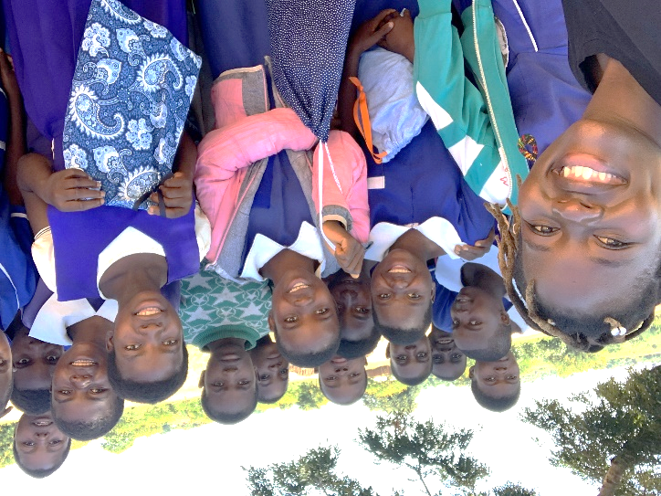
HYGIENE PADS FOR GIRLS to keep girls in School and to support WOMEN. Malawian women’s leaders said on our April trip:
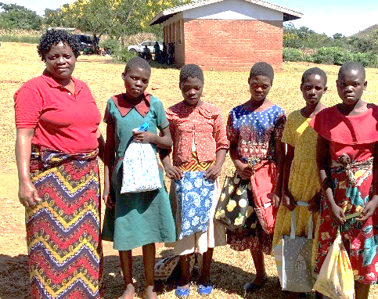
“We needed at least 400 packets and you only brought about 300.” A packet is six pads, soap, and 2 pair of underwear.
“I want to be sure the teachers have packets, as well as the girls.”
“Women knock on my door to see if there are any extras left.”
Pads packets were taken to three village schools, the Nkhoma town school, Ebenezer School, and a women’s village development meeting.”
MEN IN THE MIRROR PROGRAM Pastors, who were trained last year said: “It has dramatically in an incredibly positive way changed my relationship with my wife and children. I am grateful.”
“After teaching Men in the Mirror to elders in my church, we elected nine women as elders and six as deacons. We would not have considered women before the course. We put a woman in charge of finances, and it’s been the best.”
The Nkhoma Synod voted to teach Men in the Mirror to all its pastors. Pastors are training the men in their churches.
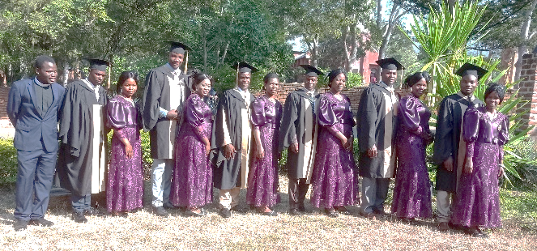
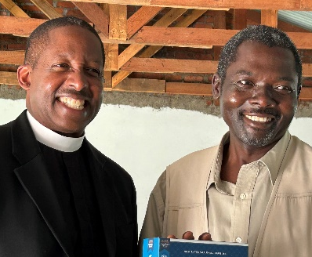
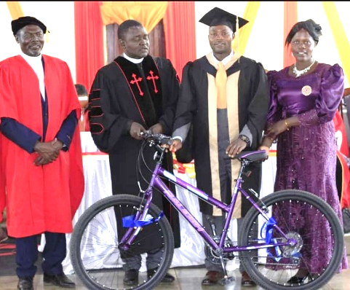
The Synod’s Seminary – Graduates got bikes, Study Bibles and clerical shirts. Also, All Seminary Students got Study Bibles

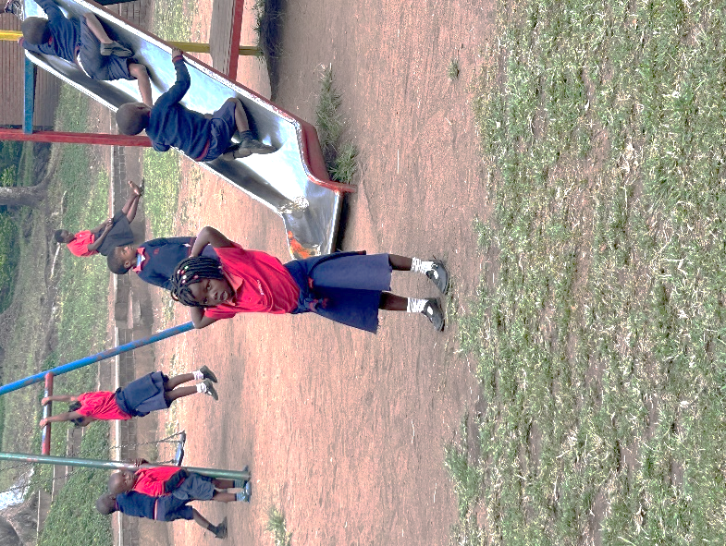
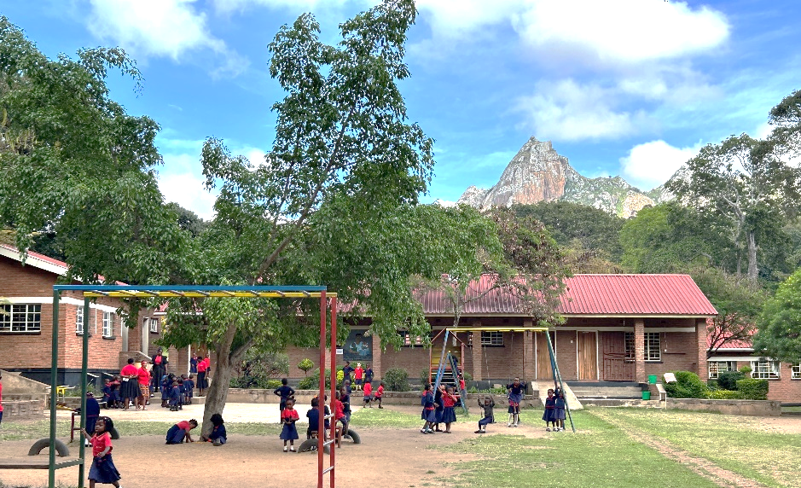
Ebenezer School – It was started with help by this Presbytery, teaches in English, no more than 30 students in a class, more than 350 students in pre-K through 8th grade. Ebenezer is supported by PWNC. More scholarship help is needed.

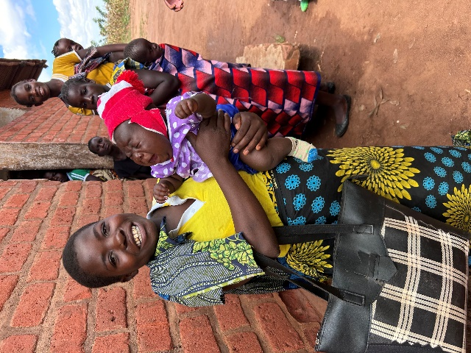
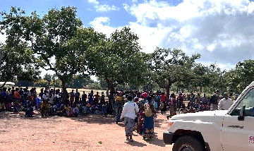
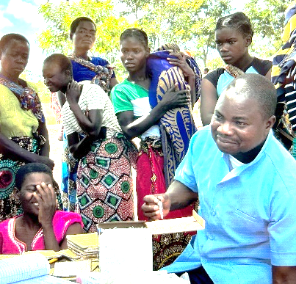
The Mobile Health Unit -Many people walk one or two hours to come to the mobile health unit. The Mobile Health Unit is supported by PWNC.

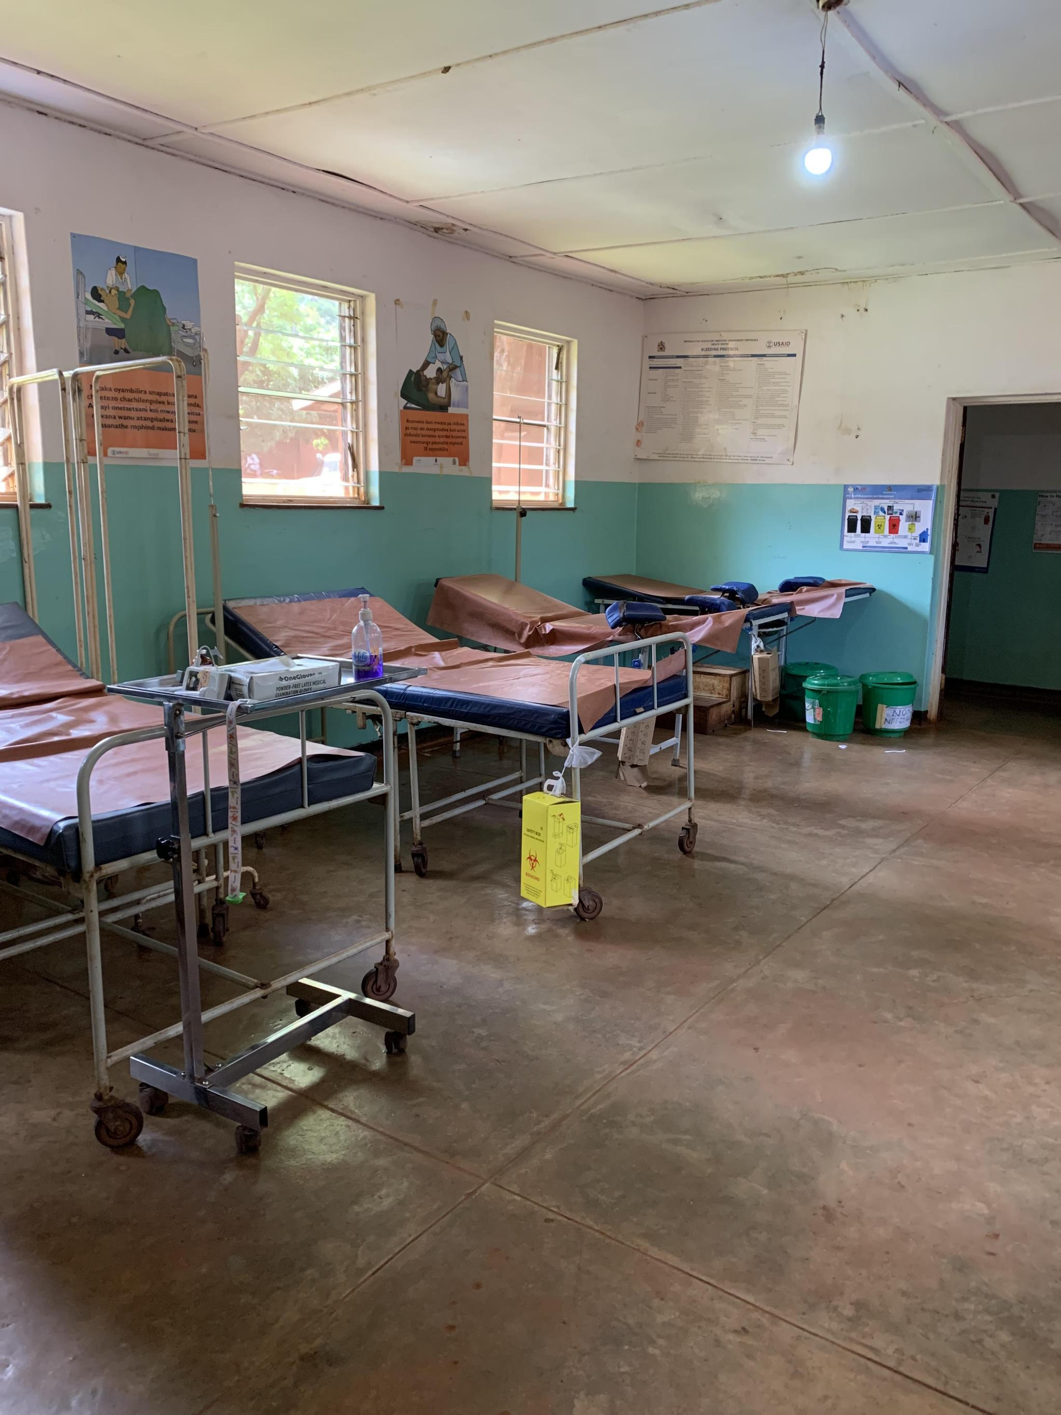
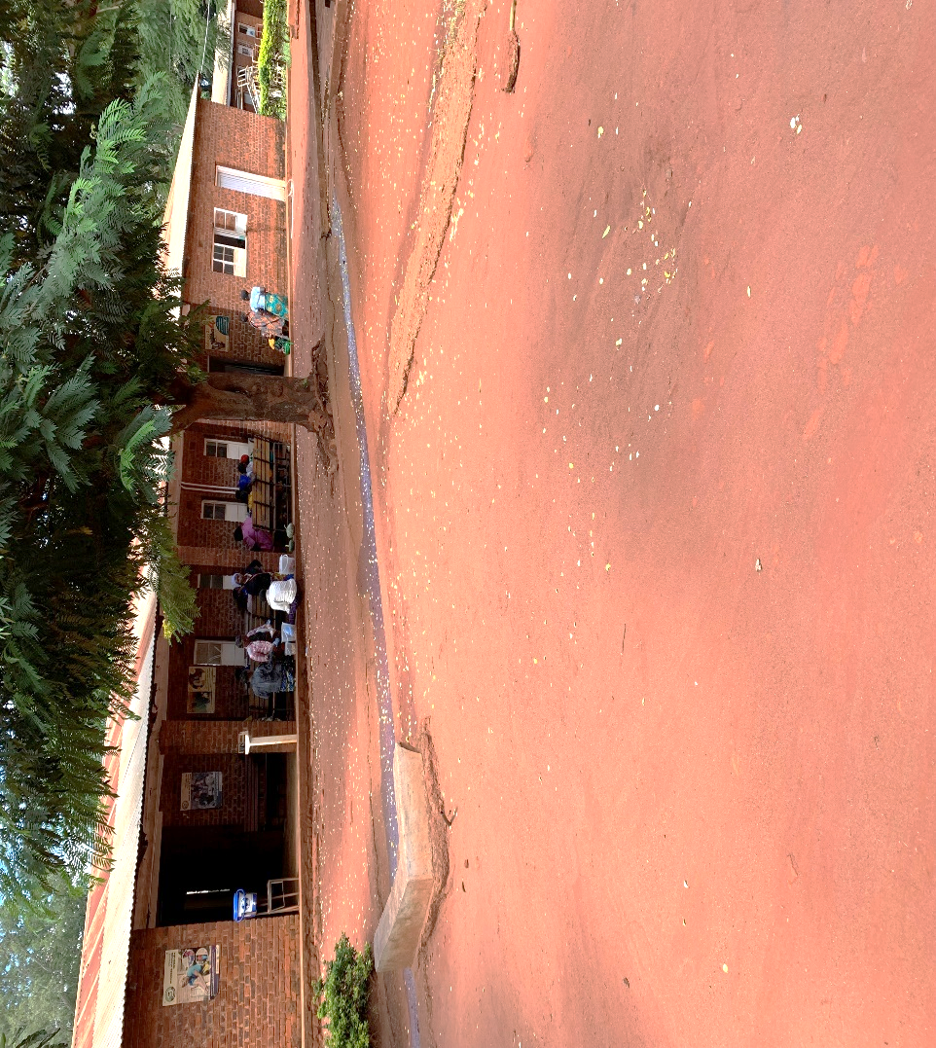
The Health Centers are important to reach people in the rural areas. PWNC has focused on getting water and electricity to all the Health Centers.
Malingunde Health Center has significant water system repair and upgrading needs to both its Center and its housing. It also has an incredible opportunity to make changes now to get access to potable water. This is in line with PWNC’s priority and funds. We are exploring this opportunity.

We also met and worked with people at the Nkhoma Synod, Nkhoma Hospital, the Chaplain’s Office, the Nkhoma University, and much more.

`JOIN US ON THE MISSION TRIP TO MALAWI IN MAY 2025!!!
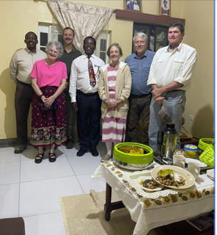
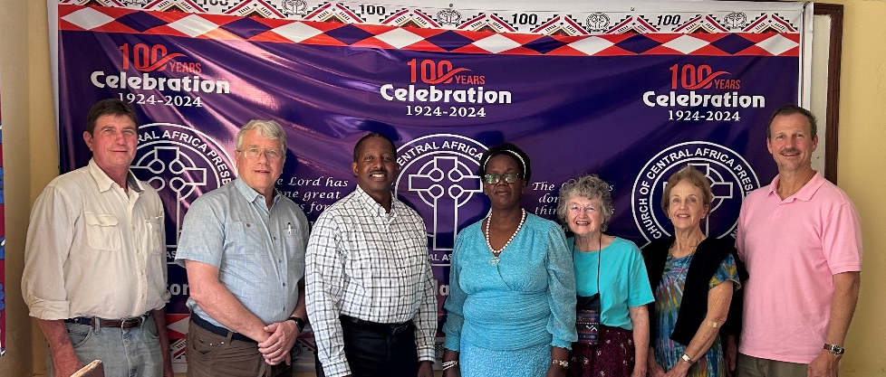
The 2024 Mission team with General Secretary of Church of Central Africa Presbyterians (CCAP) in Malawi, Zambia, and Mozambique. And the Mission Team at a feast at the home of Chief Chaplain in Nkhoma Hospital.

